Instructions for Preparing a Summary for the
13th International Symposium on Vibrations of Continuous Systems
Name1 A. Surname1*, Name2 B. Surname2#, Name3 C. Surname3†, Name4 D. Surname4†
* Faculty of Mechanical Engineering  University of Technology  Address, Postcode City, Country  email1@address | # Institute for Dynamics  University of Technology  Address, Postcode City, Country  email2@address
† Institute of Mechanics
University of Technology
Address, Postcode City, Country
[Surname3.Name3, Surname4.Name4]@address
Summary
Authors are requested to email a 3 page summary (including references and figures) no later than February 28, 2023, to:
erasmo.carrera@polito.it

The uploaded file must be in PDF format and the file name should conform to the following example: Surname1Surname2Surname3_summary.pdf.

The summary must be written in English. It must contain the full names, addresses and e-mails of the authors. In case of joint authorship, the name of the speaker who will present the paper at the conference should be underlined. The reference marks can be omitted if all authors have the same affiliation.

Equations must be numbered continuously using right flushed Arabic numbers in parentheses as shown in Equation (1):

. | (1)

All symbols of the equation should be explained. The equations can be built with the Microsoft Equation Editor using the following sizes: Full 11pt, Subscript/Superscript 7pt, Sub-Subscript/Superscript 5pt, Symbols 16pt and Sub-Symbols 11pt.

Figures and graphs must be included using the same style as shown in Figure 1. The contents of the Figure should be explained in its caption.

A resolution of 300dpi for pictures and 600dpi for line art is suggested, 1px-wide lines in figures should be avoided as they may become invisible in print. There is no limit on the number of figures as long as the total length of the paper is within the specified limit. Figures should be centered on the page.
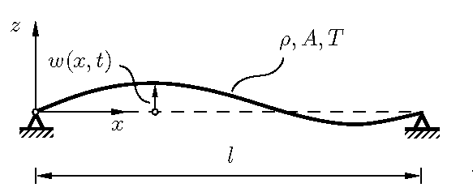
Figure 1. Example of a figure and its caption.

Tables must be included using the same style as shown in Table 1. The contents of the table should be explained in its header. Tables should be centered.

Table 1. Example of a table.
T11 | T12 | T13 | T14
T21 | T22 | T23 | T24

References should be sorted in alphabetical order as shown below, where [1] exemplifies the case of a textbook, while [2] is an article in conference proceedings and [3] is an article in
a journal.

References
- Hagedorn, P.; DasGupta, A.: Vibrations and Waves in Continuous Mechanical Systems. Wiley, 2007.
- Kennedy, D.; Ilanko, S.; Mochida, Y.: Understanding spurious modes of structures with voids using dynamic stiffness method. ISVCS 2013 - Proceedings of 9th International Symposium on Vibrations of Continuous Systems, pp. 37–39, 2013.
- Leissa, A.W.; MacBain, J.C.; Kielb, R.E.: Vibrations of Twisted Cantilevered Plates– Summary of Previous and Current Studies. Journal of Sound and Vibration, Vol. 96, No. 2, pp. 159–173, 1984.

